Dear Sir or Madam
The Institute of Education of the University of Tartu offers free participation for all citizens of Georgia, Moldova and Armenia in Microdegree “Use of technology in contemporary learning”.
Please share following information and invitation with in-service educational workers. Thank You!
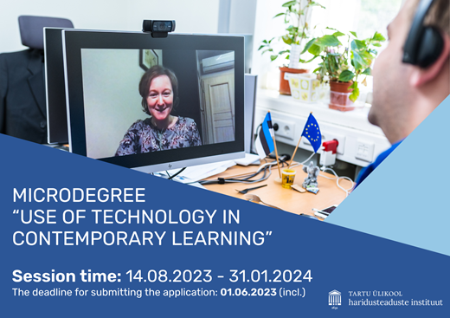

Microdegree “Use of technology in contemporary learning”

University of Tartu offers free participation for Georgian, Moldovian and Armenian citizens in Micro degree “Use of technology in contemporary learning”. If you have Bachelor's degree or equivalent qualification, the Microdegree “Use of technology in contemporary learning” offers the possibility to develop your capacity to meaningfully use technology in education. During the micro degree you will also have the opportunity to be part of an international community of educational researchers and practitioners devoted to studying and exploring the role of educational technology in contemporary learning.
The format of the degree is blended, and it will cover one semester. It will start in August with an onsite session with dedicated workshops on Technology Use in Education. It will then continue from September onwards with a number of online courses dedicated to the study of Digital Literacy, New Learning Paradigm and Critical Issues of Technology Use in Education.
The microdegree is specifically designed for those who are working full-time or who would like to develop professionally in the area of educational technology. Also, the credits awarded during the micro degree (17ECTS) can be taken into account in the completion of the master’s programme in Educational Technology (60 ECTS).
You are welcome to join the introductory webinar about the Microdegree on 16th May at 4-5 pm (Estonian time)
Let us know if you plan to participate: https://forms.office.com/e/AFuaw2GRBB
The course is in English.
Conditions for starting studies: Bachelor's degree or equivalent qualification (must be obtained by the end of June) and at least 3 years professional experience in a teaching position or in a position in which teaching staff are supervised or advised. The candidates with a master's degree or equivalent qualification do not need to prove their work experience.
The deadline for submitting the application: 1.06.2023 (incl.)
Session time: 14.08.2022 - 31.01.2023
Price: Free for Georgian, Moldovian and Armenian citizens
Teaching volume: 17ECTS (442 academic hours (70 hours of lectures, 372 hours of independent work))
Registration: https://www.is.ut.ee/pls/ois/!tere.tulemast?leht=OK.AY.VP&id_ay_programm=53635&id_ay_toimumine=69891&systeemi_seaded=10,2,12,1,
Further details:
Emanuele Bardone
(emanuele.bardone@ut.ee or +372 5688 7686)

